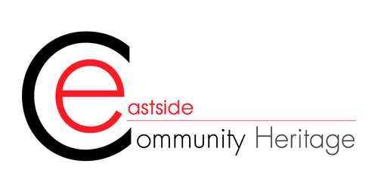

Archive Volunteer
Project Linked to: Secrets Shared
Name of Supervisor: Aiden Chan
Duration of Volunteering: 3 Months Plus

Eastside Community Heritage’s mission is to uncover the histories of people which would otherwise permanently be hidden from history. Our work is far reaching; we source stories, from working class communities, the economically disadvantaged, immigrant communities and from disabled people. It is these stories that ECH has sought, discovered, recorded, exhibited and published, highlighting their historical significance, and opened up heritage to new audiences. Today, our Hidden-Histories Archive contains over four thousand digitalized oral histories of Londoners and approximately 40,000 digital photographs.
As part our project ‘Secrets Shared: Unlocking Hidden History’ funded by the National Lottery Heritage Fund, we are currently recruiting volunteers to support the Project Archivist in improving the archive’s digital accessibility through cataloguing and digitalising materials. The project also aims to increase opportunities for community engagement, as well as disseminate digital and archival skills to volunteers and the community.
Time Commitment and Training and expenses
We’re looking for volunteers who are available on Mondays or Fridays, and able to work in person in our offices, for either a morning or afternoon session.
We can reimburse Travel expenses up to £5 a day.
What you’ll be doing?
- To support the Project Archivist in their role in cataloguing the existing and new collections of Hidden History Archive
- To list and catalogue the oral history and photograph collection
- To digitise photographs and memorabilia collected that we collect oral history interviews using scanners, cloud storage solutions and Digital Asset Management system
- To facilitate transcription of oral history interviews using Otter.ai

No specific experience is required for this role – you’ll be trained on archiving techniques but to get the most out of this role you should be/have:

- An enthusiasm for archives and the heritage sector
- An interest in social history and local history of the East End of London
- Good written and communication skills
- Basic computer skills (including Microsoft word)/Willingness to develop skills
- Comfortable working independently
Why get involved?
- Be part of an exciting community archiving project
- Take part in Archive training from our project archivist
- Learn new digital skills while using Otter.ai
- Be part of an exciting community archiving project
- Meet and befriend other staff and volunteers.
- Feel more connected to East London

How to get involved?

Complete an application form here: https://forms.office.com/e/LxshqVytyZ

