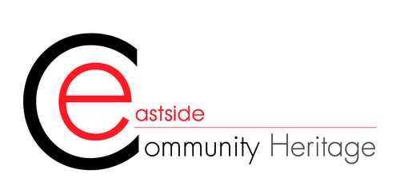

Oral Histories Description Volunteer.
Duration of Volunteering: 3 Months Plus

Eastside Community Heritage’s mission is to uncover the histories of people which would otherwise permanently be hidden from history; from working class communities, from the economically disadvantaged, from immigrant communities and from disabled people. It is these stories that ECH has sought, discovered, recorded, exhibited and published, highlighting their historical significance, and opened up heritage to new audiences. Today, our Hidden-Histories Archive contains over four thousand digitalized oral histories of Londoners and approximately 40,000 digital photographs.
We’re looking for volunteers to support upcoming oral history projects, helping record interviews with community members across East London and transcribe fascinating social histories. In this role, you’ll take on two specific aspects – oral history interviews, which focuses on collection of stories, and transcribing, adapting our audio files to usable text for exhibitions and publications. These two tasks form help us add to our ever growing Hidden-Histories Archive.
Time Commitment and Training and expenses
As well as an ongoing week day commitment, in order to undertake this role, you will need to be available on two weekdays for Oral History Training OR initially start transcribing for the first few months (In order to gain context otherwise gained in the two days of set training)
We reimburse travel expenses up to £8 (with receipts).
What you’ll be doing?
- Transcribing Oral History Interviews
- Providing Support with the archiving of oral history in the London Peoples Archive
- Assisting with outreach events and exhibition launches
- Undertaking Oral History Training and conducting interviews
- Assist the public with basic enquiries and signposting.

No specific experience is required for this role, but to get the most out of this role you should be/have:
- An interest in local history and working with communities.
- Comfortable using a computer for typing up transcripts.
- Reliable, professional and punctual
- Interested in local History and Working with Communities.
- Comfortable working alongside the public.
- A good communicator and listener.

Why get involved?
- Be part of an exciting local history project.
- Receive fantastic oral history training from our team.
- Meet and befriend other volunteers.
- Feel more connected to East London
- Gain valuable skills in interviewing.

How to get involved?

Complete our online application form: https://forms.office.com/pages/responsepage.aspx?id=9lUAH2ORkEmFZLoVfFQqeB1NnpQnOnxAhGBe7truEM1URVNRVjZLNk1OT0pBVE5GVU1RWDlBRlpBUi4u

